**User Manual for CAN Configuration Software**

**How to Use the Software**

**1. Launch the Application**

* Double-click on the application icon to open the software.
* The graphical user interface (GUI) will appear on the screen.

**2. Connecting to the CAN Bus**

* Ensure your CAN device is plugged into the system.
* Ensure that PCAN basic API driver is in system and gives the dll path in system variable of environment variable.
* Select Proper Channel and Baud rate
* Click on the **Connect** button in the application.
* A status message will confirm if the connection is successful.
* After Connected Successfully then wait for receiving **Heartbeat**

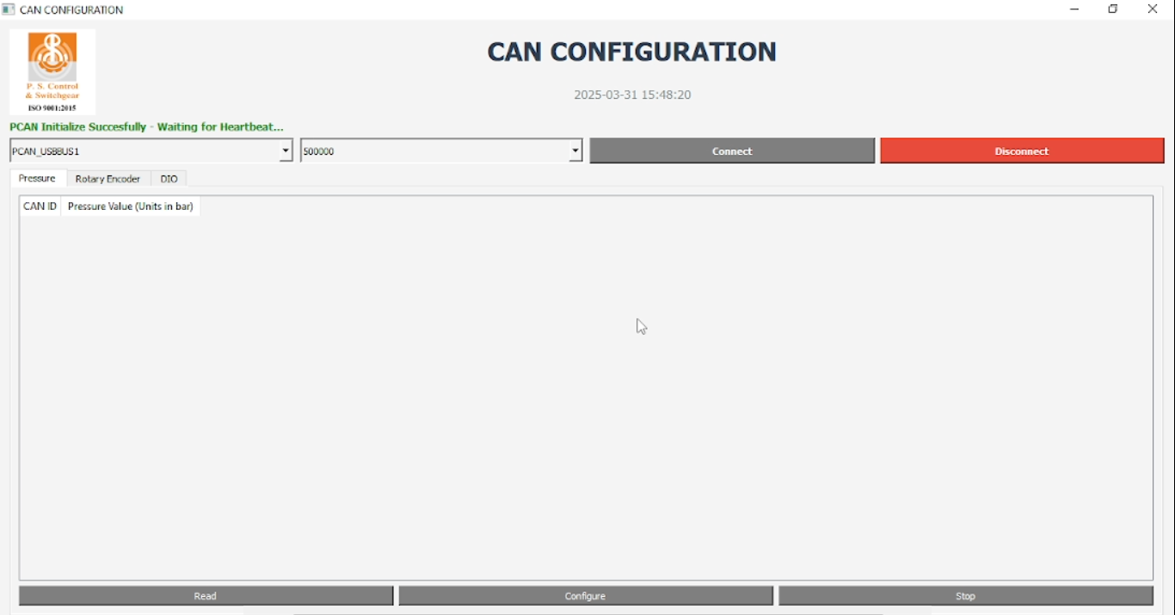

1.Select Channel and Baud Rate.

2.Click on Connect Button

3.Wait for Heartbeat

**3. Reading Data**

* After Receiving Heartbeat Nodes then Click on the **Read** button to fetch data from the CAN bus.
* The received messages will be displayed in a structured table showing the CAN ID and CAN data.
* Verify the Node ID in the displayed data.
* Before Reading any data ensure that current process has been terminated by clicking on **Stop** Button.
* For example – If you start reading DIO data by clicking the **Start** Button and later want to read Pressure data, you must first stop the DIO data by clicking the **Stop** button in the DIO tab before starting the Pressure data read.

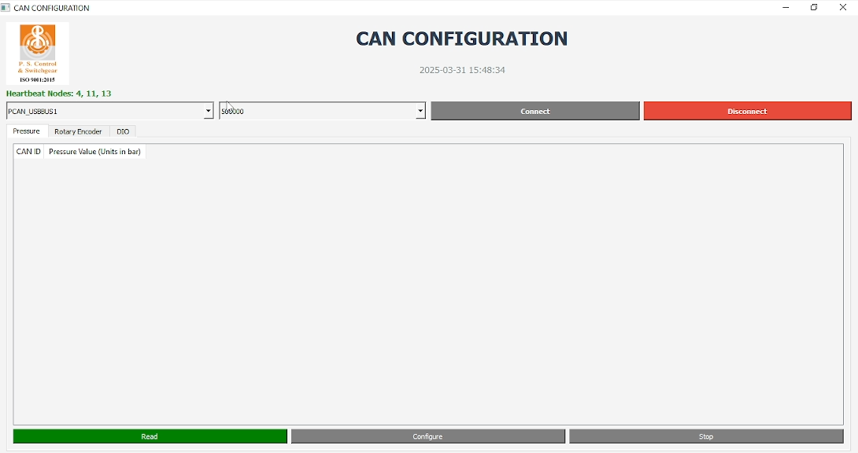

2.Click on Read Button

1. Heartbeat Node Fetched Successfully

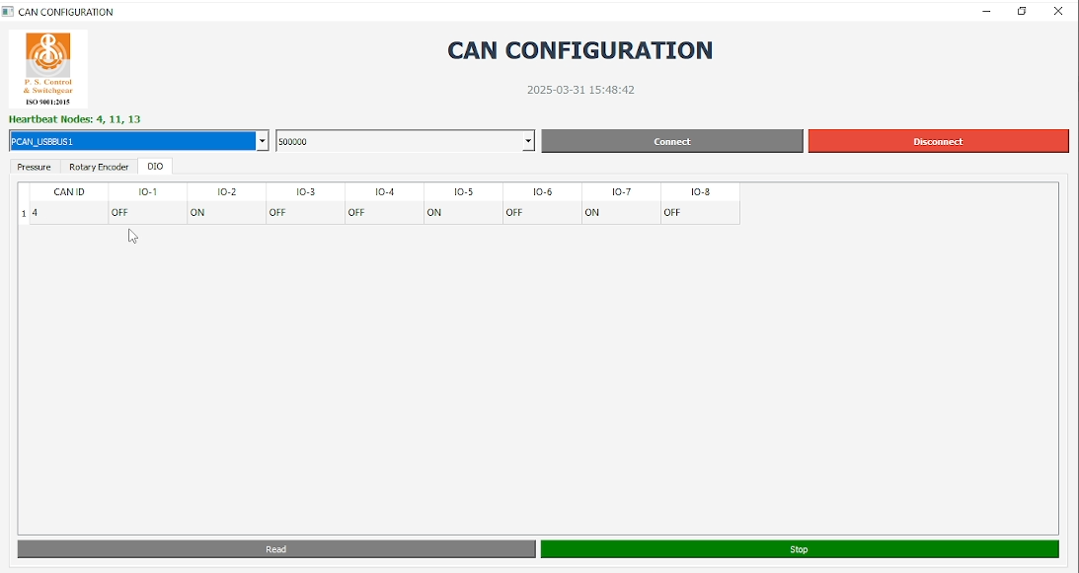

4.Click on Stop Button

3.Recived CAN Data with ID

**4. Configure New Node ID**

* Click on the **Configure** section in the application.
* Click on the **Configure** Node ID button
* Select the current node you want to change from Current Node ID dropdown.
* Enter the new **Node ID** in the Replace ID field.
* Wait for the process to complete.
* Disconnect the bus from the system and reconnect it. The updated Node id should now be.

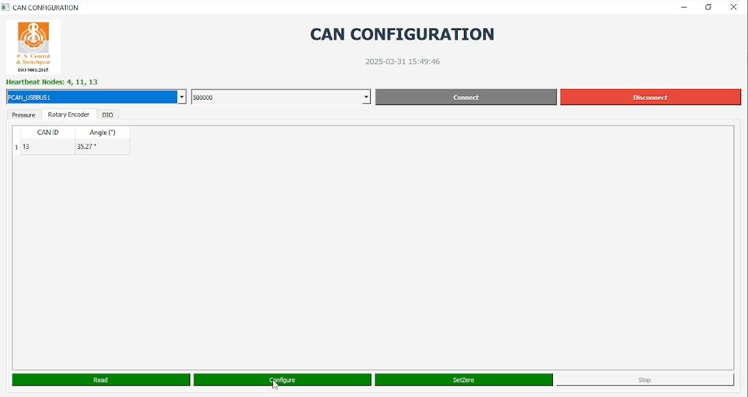

1.Click on Configure Button

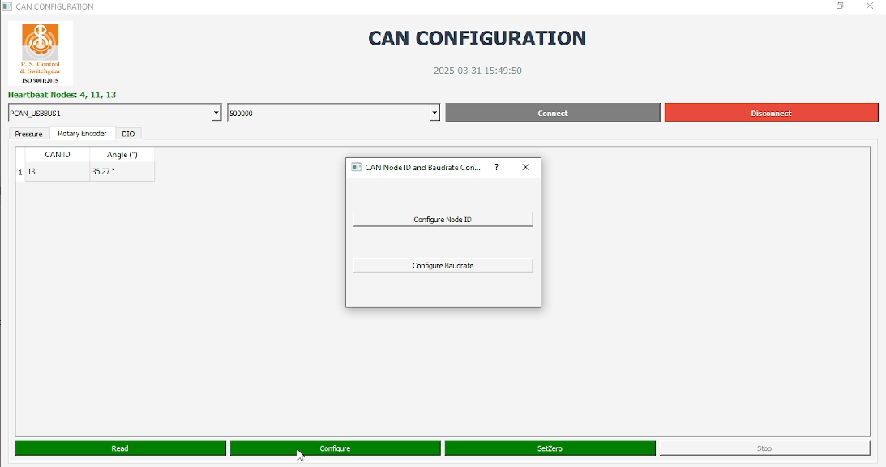

2.Click on Configure Node ID Button

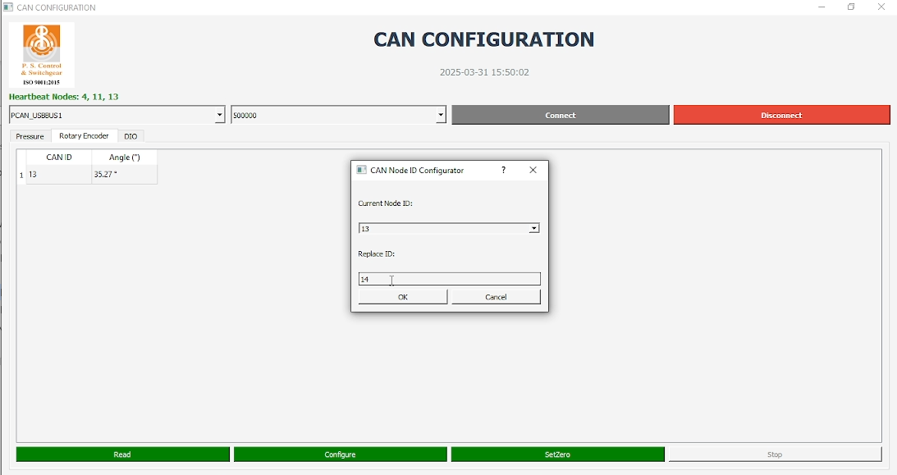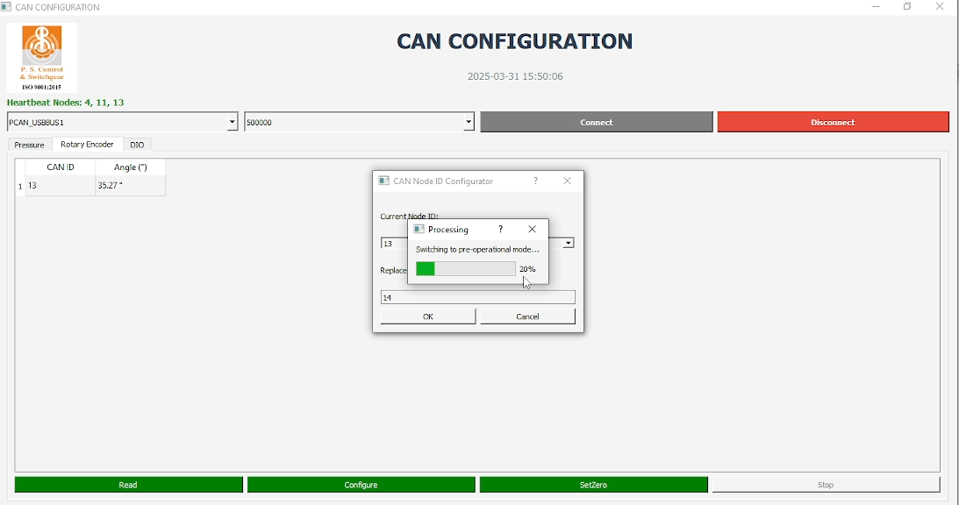

3.Select Current Node ID or which Node ID you want to be change

4. Write New Node ID in Replace ID field and click on Ok Button.

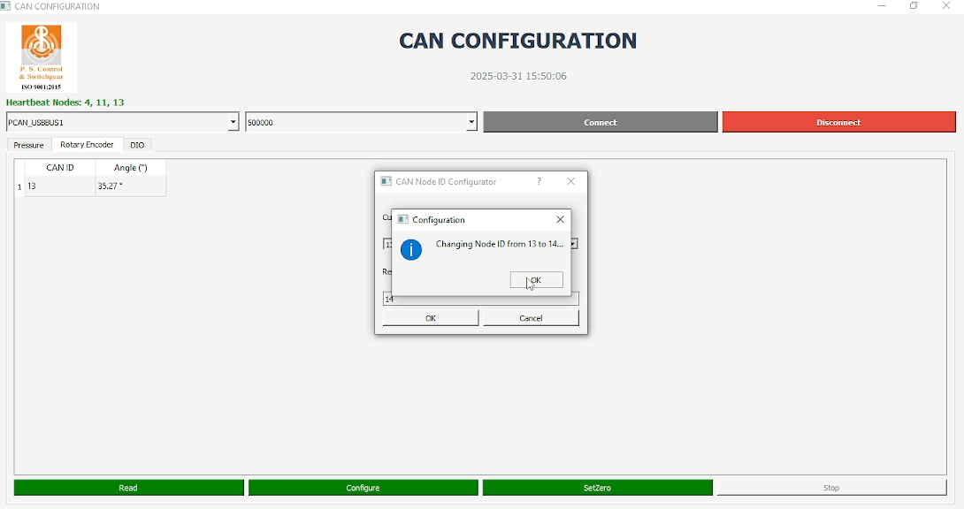

5. Click on OK button and wait for the process to complete.

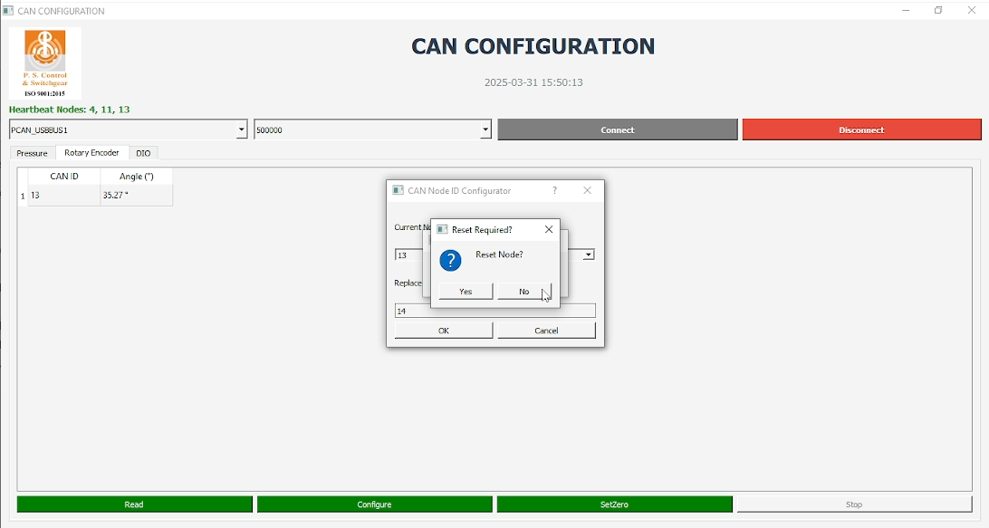

6. Click on Yes button and wait for the process to complete.

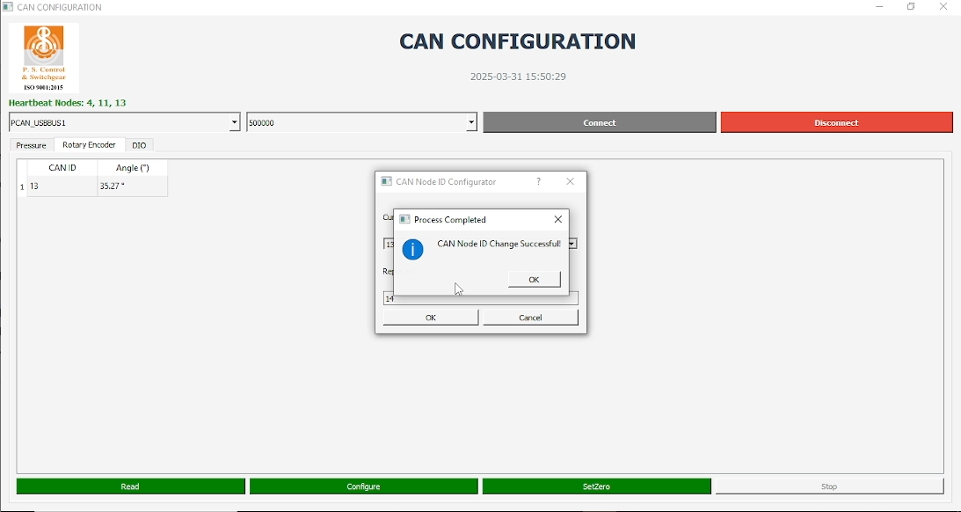

7. Node ID changed Successfully Disconnect the bus from the system and reconnect it.

**5. Configure For Changing Baudrate**

* Click on the **Configure** section in the application.
* Click on the **Configure** Baudrate button
* Select the current node you want to change from Current Node ID dropdown.
* Select the new baud rate from Baud Rate the dropdown.
* Wait for the process to complete.
* Disconnect the bus from the system and reconnect it. The node should now operate with the new baud rate.

**6. Handling Errors**

* If an error occurs, a message will appear in the application.
* To resolve common issues:
  + Restart the application.
  + Check the connection of the CAN device.
  + Ensure the correct CAN interface is selected.

**7. Exiting the Application**

* Click on the **Exit** or **Close** button to terminate the program.
* Ensure all processes are stopped before closing.